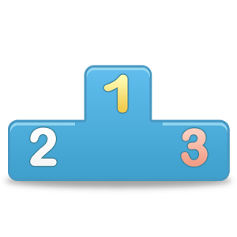
This month’s Pick for your ANDROID platform is...
PRIORITIZE ME!

Prioritize Me! App provides the user with the opportunity to be prompted on which tasks for daily to-do lists or goal planning are most important. The app creates customized lists by highlighting the most important goals/tasks. The built in features help rank your tasks by asking you questions on which are most important when put up against each other. Try this app out to help get your goals, to-do’s and reminders organized based on importance.

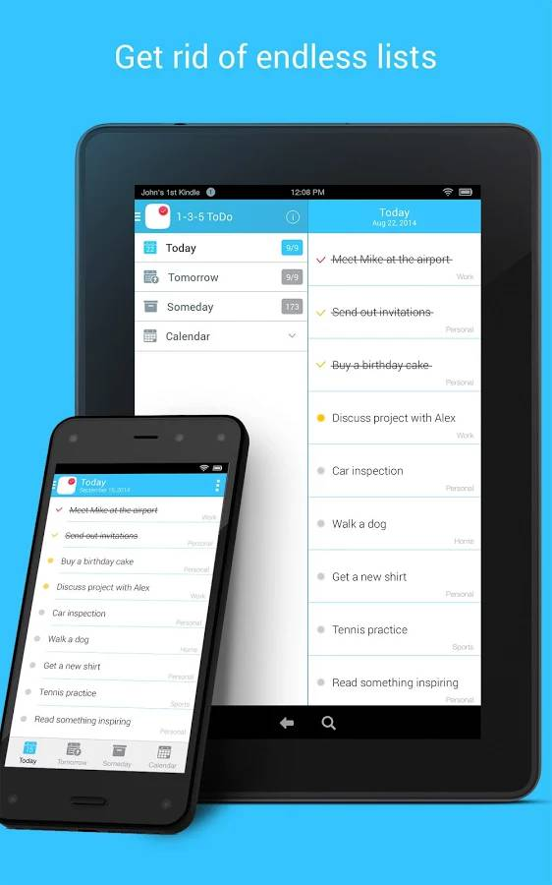
Features:

- Helps rank a series of goals or tasks which are most important to be completed
- The prioritizing software asks a series of questions to generate a list based on importance
- Make to-do lists, reminder lists, goal lists, planning for events or tasks lists, steps to complete multiple level tasks etc.
- Can copy and paste already created lists into Prioritize Me!
- Allows you to tick off and scratch off tasks as they are completed to see your progress
- Can share your lists through email or text message right from the app
- Pro Version: removes all ads and pop-ups! As well as provides you with unlimited history records of tasks completed
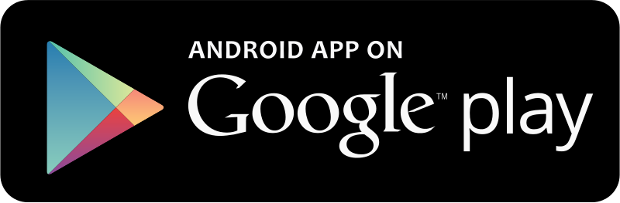
FREE Android users only
Created by Tonya Lambert, CDA, Technology Consultant
Lear Communication February 2016

